Release Form

Integrating Caring Science into Interprofessional Education & Practice Tool Kit

Terry Eggenberger, PhD, RN
Kathleen Valentine, PhD, RN
Kathryn Keller, PhD, RN

You have our permission to use a version of the Integrating Caring Science into Interprofessional Education & Practice Tool Kit © 2017

Please complete the items on the following form and return by email to Dr. Terry Eggenberger at teggenbe@health.fau.edu. We ask your permission to share your name and email of completed projects with future peers interested in a similar use of the project. Signing and scanning this form grants us this permission.

Name: | Degrees and Certifications:
Address:

Employer:

University:

Phone-Cell: | Phone-Work:
Phone-Home Land: | Other Phone:
Email Address: | Second Email Address:

- Very briefly describe your applied use of the Tool Kit:

- Estimate how many subjects/participants/students will be involved in the application of the Tool Kit.

- Identify which part/section of the Tool Kit will be used in your study/project/classroom, etc. Please specify.

I will notify the colleagues noted above when a publication that results from Tool Kit use is available, so that they may also cite your work. Continue to send your current address and email changes.

___________________________________________ _______________
Signature Date

___________________________________________
Print

Please retain one copy of this form for your records and send the original back as a scanned pdf.

Thank you for your interest in the Integrating Caring Science into Interprofessional Education & Practice Tool Kit.

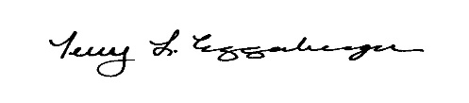
Terry Eggenberger, PhD, RN, NEA-BC, CNE, CNL, FNAP
Associate Professor
Director of Interprofessional Education & Practice
Florida Atlantic University
Christine E. Lynn College of Nursing
777 Glades Road, NU 328
Boca Raton, FL 33431

